学信网采集码获取方式
How to get the QR code from CHSI web？
学信网身份认证原理：
在你入学的时候，学校会上传你的学籍信息到学信网，学籍信息有问题的话，老师有权限修改。
你自己在学信网注册的时候，你的账号信息要和学校当时上传的一致，学信网才能把你认证成浙江大学的学生。你注册页面的问题，学校这边是看不到的，也没有权限修改。需要你自己修改或者联系学信网客服。
CHSI identity authentication principle:
When you are enrolled to Zhejiang University, the school will upload your student status information to CHSI. For this page, we have the right to modify the student status information.
When you register your account on CHSI, the name and passport must be consistent with the school upload at that time, in order to certify you as a student of Zhejiang University. The problem of your registration page can not be seen by the school, and the school has no permission to modify it. You need to modify by yourself or contact CHSI customer service.
- 登录学信网（https://www.chsi.com.cn/）
Login the CHSI web（https://www.chsi.com.cn/）
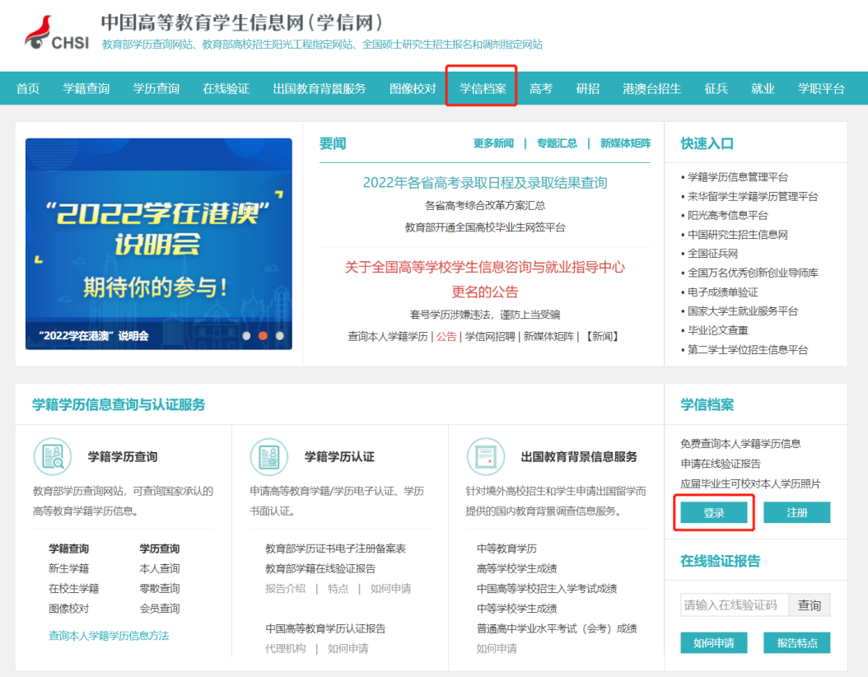
- 如果从来没有注册过账号，请先注册学信网账号
If you have never registered an account before, please register a new account first.
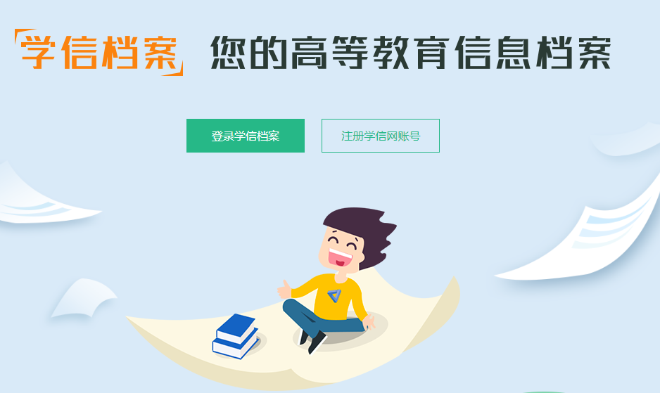
姓名：填英文名（字母全部大写），登录浙江大学研究生系统(yjsy.zju.edu.cn)，打开毕业信息核对，按照页面的“姓名拼音”完全一样填写（包括空格、前后顺序要一模一样）。
Name: Fill in the English name which is exactly the same (including the space and the order) with the 姓名拼音 in the graduation information check page of the yjsy.zju.edu.cn web).
如果研究生院系统姓名拼音有误，请联系zhouxiaoling@zju.edu.cn申请修改（附上护照和学号）。
If the name of the graduate system is incorrect, please contact zhouxiaoling@zju.edu.cn to apply for correction (with passport and student number attached).
学信网我们会马上改掉，研究生院系统会统一向研究生院提交申请，等研究生院审核后会改好。
We will modify it immediately on CHSI, and for the graduate system, we will submit an application to the graduate school and it will be modified after the approval.
如果你之前注册的时候填错信息了，下载学信网app注销旧账号。按照上面的说明注册一个新账号。
If you filled in the wrong information when you registered before, download the 学信网app to cancel the old account. Follow the instructions above to create a new account.

证件类型：选择护照
Document type: Select Passport
证件号码：填写你当下使用的最新的护照
Document number: Fill in the current passport number you are using
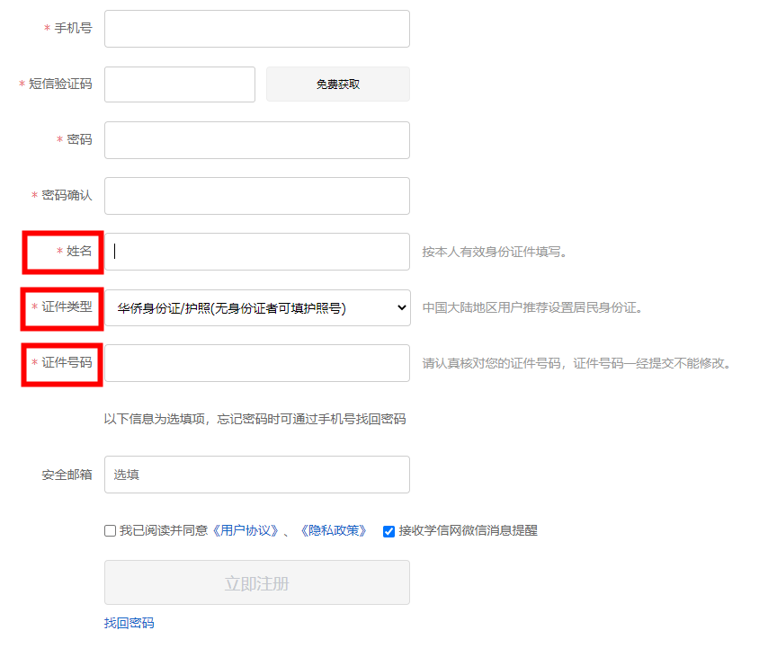
所有内容填写完成，点击立即注册。
After all is done, click Register Now.

- 注册成功以后点击登录，查看本人学籍信息
After registered successsfully, click login to view your student status information
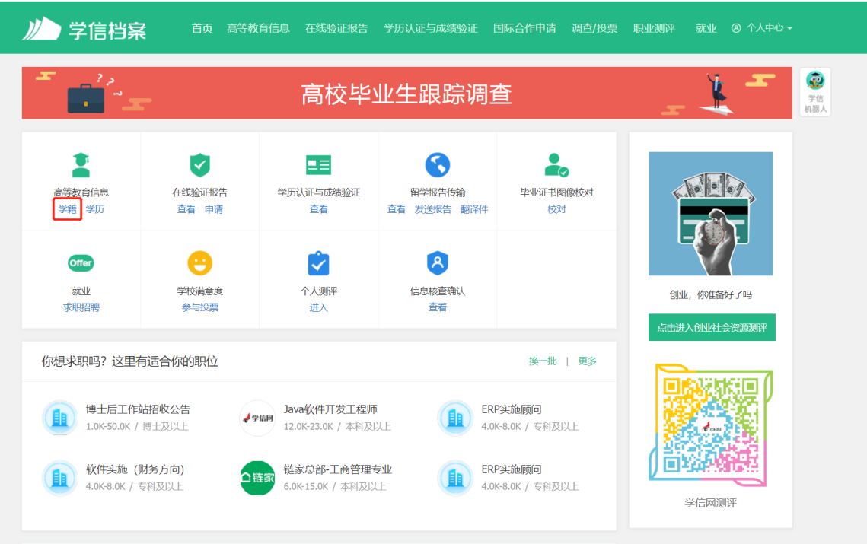
- 选择学籍，会出现“本人身份核验”
Click student status, "My identity check" will appear.
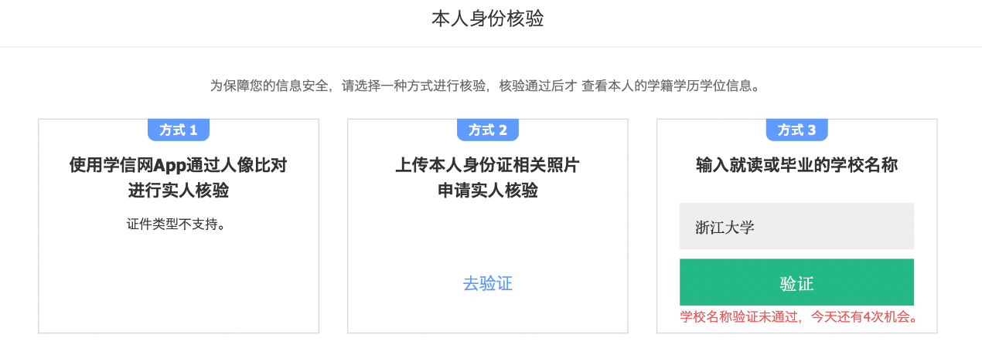

- 可以先选择方式3输入浙江大学，一般就能通过并且获取到采集码了（如果验证未通过，请查看步骤6）
First you can select method 3 to enter Zhejiang University. Generally it can pass and you get the QR code (if the verification fails, please go to step 6

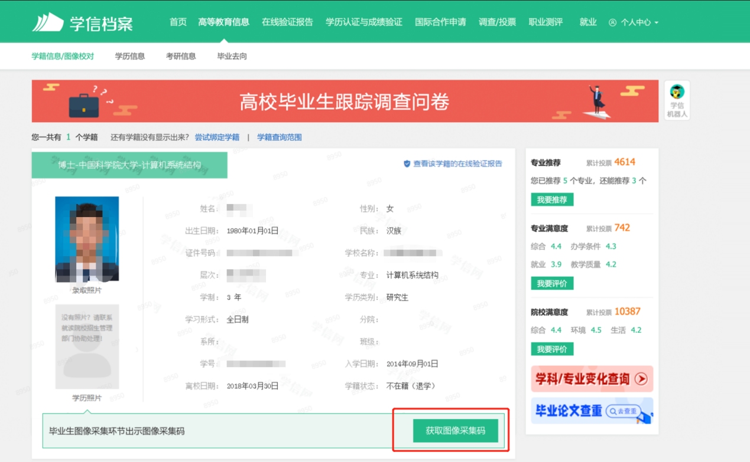
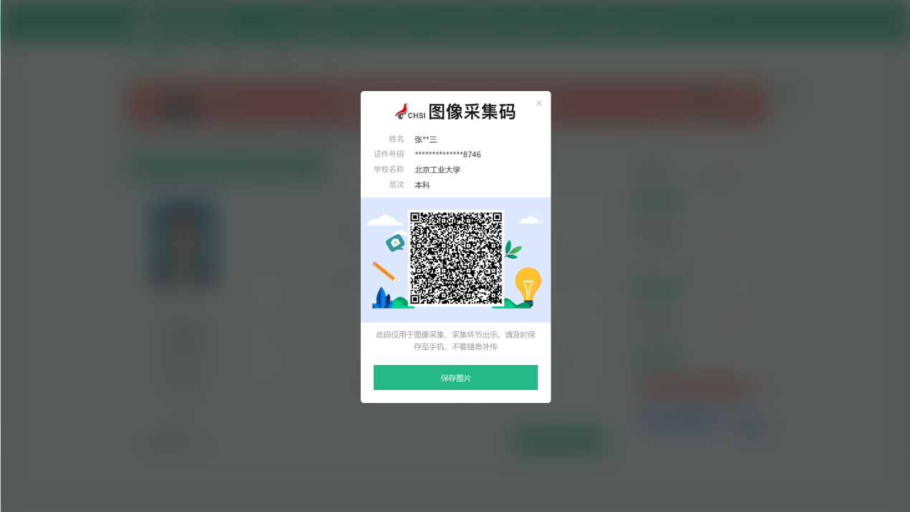

- 如果提示学校名称验证未通过，联系zhouxiaoling@zju.edu.cn，发送学号申请查看学校为你录入学信网的学籍信息。
If the university name verification fails, contact zhouxiaoling@zju.edu.cn and send your student number to apply for checking the student status information uploaded by the university.
- 仔细检查老师发你的学籍信息，跟你的护照、你注册学信网时候填写的信息是否完全一致，如有错误，请邮件回复正确信息，附上护照等证明材料。
Carefully check the student status information sent by us and make sure it is completely consistent with your passport and the information you filled in when you registered on CHSI. If there is any mistake, please reply the correct information by email and attach the passport and other supporting documents.
- 待老师将你的信息更正以后，再次回到步骤5，通过学校验证。
After we has corrected your information, go back to step 5 again and try the university verification.
- 如果信息完全正确，还是无法通过验证，就切换到方式2上传护照验证。
If the information is completely correct and you still fail to pass the verification, switch to Method 2 to upload passport for verification.
- 证件类型选择“其他”
Select “Other” as the document type
- 按照要求上传四张照片：
Upload four photos as required:
第一张照片请手拿着护照有照片那页拍摄，需要能够清楚看到信息和你的人脸；
Firstly, upload picture of the passport photo page held by you. Your face must be clearly visible, including ears, forehead and clearly visible passport (see example bellow).
第二张照片请手拿着护照的封面拍摄，需要能够清楚看到信息和你的人脸；
Secondly, upload picture of the passport cover page held by you. Your face must be clearly visible, including ears, forehead and clearly visible passport.
第三张照片请拍摄护照上的照片页；
Thirdly, upload picture of only the passport photo page with clearly visible content.
第四张照片请拍摄护照的封面页。
Lastly, upload picture of only the passport cover page with clearly visible content.
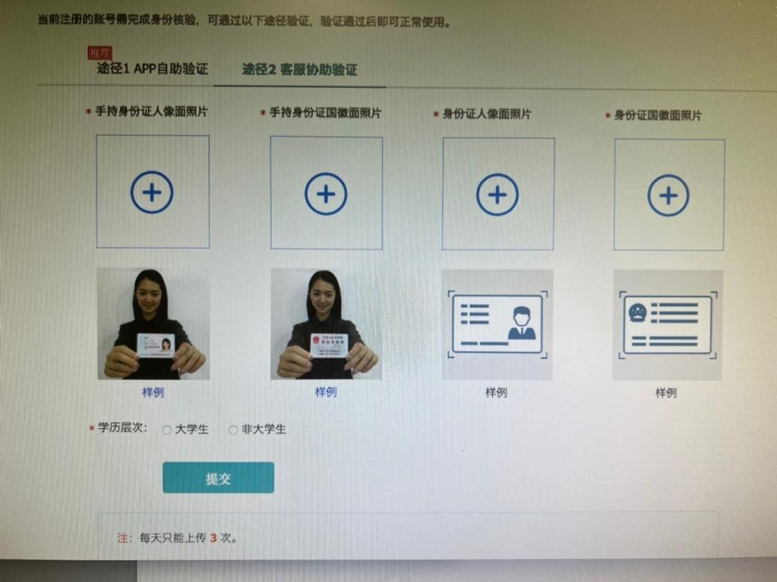
10.待审核通过以后，再次尝试点击学籍获取采集码。
Submit these pictures and wait for verification. The usual timeframe is within 1-2 hours but the they reserve the right to reply within 3 days. After the verification is passed, try to click on the student status again to obtain the QR code.
备注：学信网非学校网站，老师看不到你们注册的页面，也无审核权限，如果以上都不能解决问题或者验证次数已全部用完，建议直接联系学信网官方咨询。可以直接拨打电话010-67410388咨询或者发邮件到客服邮箱kefu@chsi.com.cn 邮件中提供你的护照姓名，手机号码、护照号码、本人手持护照的照片、报错截图，等待客服后台他们审核通过后，及时使用该手机号重新注册。

Note: CHSI is not belong to Zhejiang University, and we have no permission to verify. If the above guidline can not solve the problem or the amount of verification has been used up, please contact the official phone of CHSI.
Tel: 010-67410388(中文);
Email：kefu@chsi.com.cn,The email provides your name, mobile phone number, passport number, picture of the passport photo page held by you，the screenshot of reporting an error.Re-register with the mobile phone number after they have approved it.

