ASRTU Arctic Summer School 2021

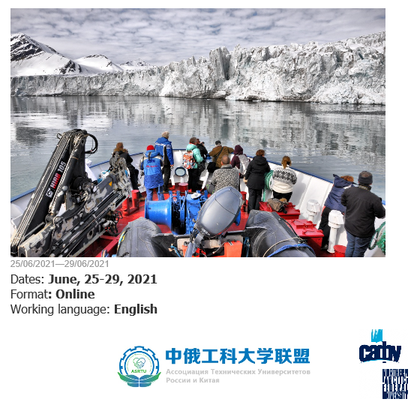
Zoom Platform, Moscow local time
Friday, 25 June
09:00 -09:30 | Logging in
09:30 - 10:15 | Opening ceremony
10:15 - 11:00 | Keynote lectures: Russian Arctic Strategy
11:15-12:00 | Konstantin Zaikov,  Northern Arctic Federal University (Russia)  Northern Territories Governance  Alexander Saburov  Northern Arctic Federal University (Russia)
12:00 – 12:15 | Break
12:15 - 13:00 | Northern Sea Route: State and Perspectives
Luidmila Siluanova
Northern Arctic Federal University (Russia)
13:00 - 13:15 | Break
13:15 - 14:00 | Environmental Challenges in the Arctic
Marina Nikitina
Northern Arctic Federal University (Russia)
14:00 -16:00 | Online tour around Arkangelsk/ Virtual excursion to the White Sea shore
Saturday, 26 June
10:00 - 11:00 | Challenges Associated with Arctic Oil and Gas Development
Prof. Anatoly Zolotukhin
Gubkin Russian State University of Oil and Gas
11:15 - 12:15 | Prospects of Using Different Energy Resources in the High North
Prof. Pavel Maryandyshev
Northern Arctic Federal University (Russia)
12:15 - 12:45 | Break
12:45 - 13:45 | Laboratory Studies of Rock Samples and Hydrocarbons in the Arctic Oil and Gas Innovative Technological Centre
Ivan Belozerov
Northern Arctic Federal University (Russia)
14:00 - 15:00 | New aspects in Reservoir Simulation  Ramil Guliev
 | Northern Arctic Federal University (Russia)
15.00 – 15.15 | Break
15:15 - 16:15 | Perspectives of Oil and Gas Resources Development in the Arctic (students group work, case contest)

Sunday, 27 June
10:00 – 11:00 Chinese lecturer (oil and gas topic)
11:15-12:15 Chinese lecturer - Environmental Challenges

12:15 - 12:30 | Break
12:30 - 13:30 How visual environment influences human
Anna Cherkasova
Northern Arctic Federal University (Russia)
13:30 - 14:00 | Break
14:00 - 15:00 | Environmental Civil/Geotechnical Engineering in the Cold Regions  Sergey Akseyonov
 | Northern Arctic Federal University (Russia)
15:00 - 15:15 | Break
15:15 - 16:00 | Students group work on the projects
Monday, 28 June
09:00 – 10:00 Chinese lecturer (ice construction)
10:15-11:15 Development of new multifunctional building materials suitable for extremely cold
weather conditions
Maria Frolova,
Northern Arctic Federal University (Russia)
11:15 - 11:30 | Break
11:30 - 12:30 Planning, design and post-evaluation of Arctic and Subarctic architectural environment
Elena Gontar,
Northern Arctic Federal University (Russia)
12:30 - 13:00 | Break
13:00 - 14:00 | "Applying the Historic Urban Landscape Recommendation to Arctic Settlements: the case of Solovetsky Islands"  Prof. Iamandi Krisitina
14:00 - 14:15 | Break
14:15 - 15:15 | Online tour around an open-air museum of the wooden architecture “Malye Korely”
15:30-16:15 | Students group work on the projects
Tuesday,29 June
09:30 -10:15 NArFU case: Arctic expeditions "Arctic Floating University"
Virtual excursion to the Ship “Professor Molchanov”
10:15 – 12:00 Students group work on the projects

12:00 – 13:00 Break
13:00 - 15:00 | Students Presentation session
15:00 - 15:30 | Closing ceremony

In case of questions, please contact coordinators:

Ms. Svetlana Pirogova,
Head of International Communications Unit,
Phone: +7 (921) 244 87 93, e-mail: s.pirogova@narfu.ru

